Notes on programming with the Arduino IDE

# The Adruino IDE must be installed and the libraries for the ESP32 be included.

Create a new sketch and save it as MiniWebRadio. The IDE creates a new folder named MiniWebRadio.

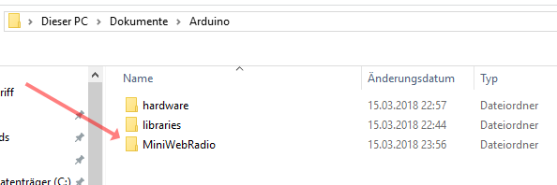

The easiest way to do this is to add all the libraries you need in this folder. The required files Can be found in my repositories.

[Https://github.com/schreibfaul1/ESP32-vs1053_ext](https://github.com/schreibfaul1/ESP32-vs1053_ext)

[Https://github.com/schreibfaul1/ESP32-IR-Remote-Control](https://github.com/schreibfaul1/ESP32-IR-Remote-Control) Optional, for a IR Remote Control)

In addition, the driver for an SPI display with Touchpad is required. For the Waveshare 2.8 inch display, the:

<https://github.com/schreibfaul1/ESP32-TFT-Library-ILI9431-HX8347D>

For other displays an adjustment is necessary. The TFT libraries from Adafruit are well suited.

If everything is included, the contents of the folder will look like this:

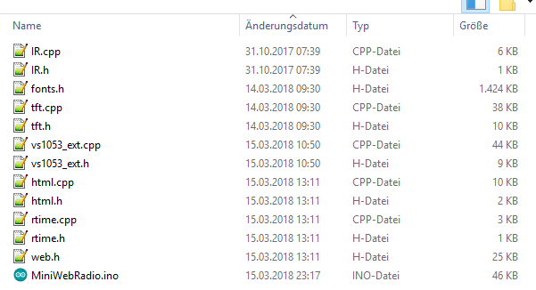

The contents of the archive **„Content_on_SD_Card. zip "**  [Https://github.com/schreibfaul1/ESP32-MiniWebRadio/blob/master/Content_on_SD_Card.zip](https://github.com/schreibfaul1/ESP32-MiniWebRadio/blob/master/Content_on_SD_Card.zip) will be unzipped to the SD card.

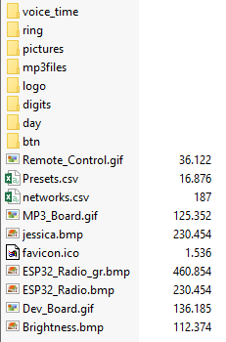

voice_time Language files for the time (can be played at any hour)   
ring MP3 file for the alarm tone  
pictures Bitmaps to test the display (not strictly required)  
mp3files Music files etc. for the MP3 player  
logo Sender logos as bitmap (96x96 pixels in size)  
digits Alarm clock and time bitmaps  
day Bitmaps for the day (alarm on/off)  
btn Bitmaps for the buttons  
preset.csv The channel list can be edited, the first 256 entries are displayed in the internal nvs stored  
networks.csv If more than one WiFi network exists, the access data can be entered here  
favicon.ico is displayed by the browser on the Web portal. The default URL is: <http://esp32radio/index.html>  
ESP32_Radio.bmp The Home screen  
Brightness.bmp Display Brightness menu graphic

Because more NVS memory is required for the channel list, the partition table must be changed.

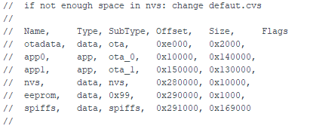

This can be done with a text editor.

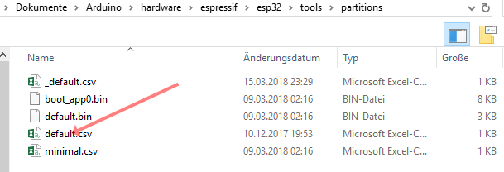

Or alternatively, the default. csv will overwrite the file from the Additional_info.

After that, the sketch can be compiled and uploaded.

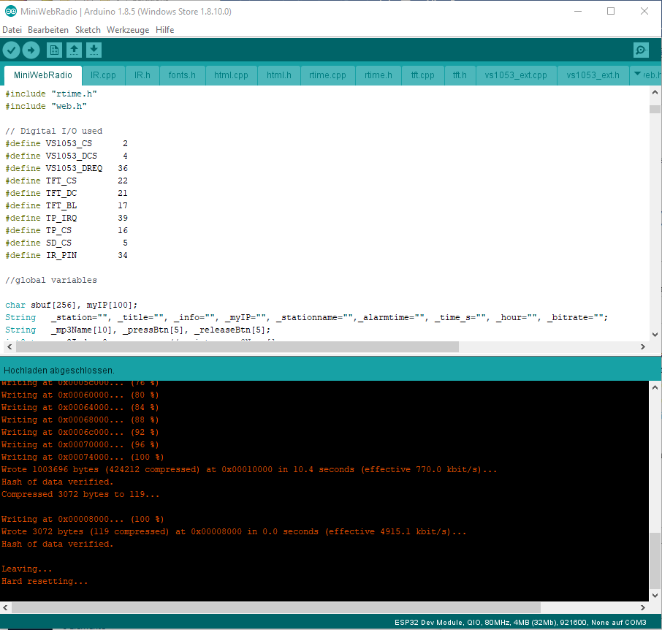

Sincerely,

**Wolle**